**Authorizing ARM Template using Visual Studio 2019**

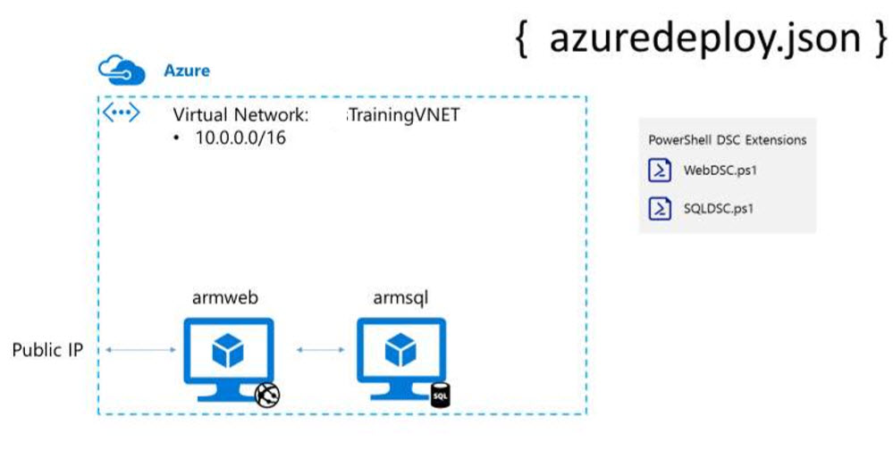

**Step 1:** Start **Visual Studio 2019**

Click on **Start** button and type or select **Visual Studio 2019**

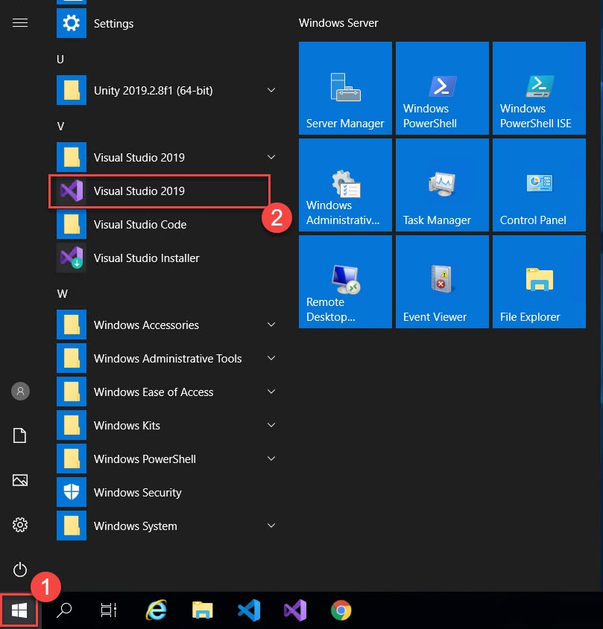

**Step 2:** Create New Project

Click on **Create a new project option**

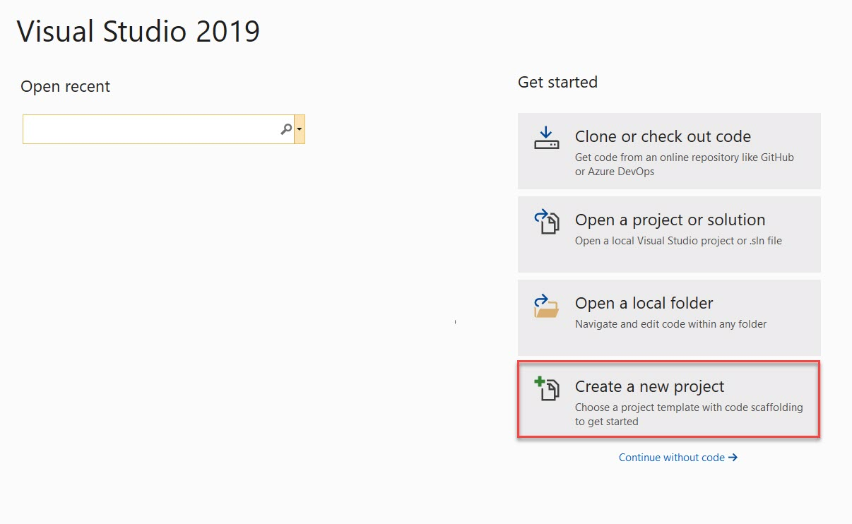

Create Azure Resource Group Project

Language: **C#**

Search for “**resource group**”

Select **Azure Resource Group** and Click on **Next** button

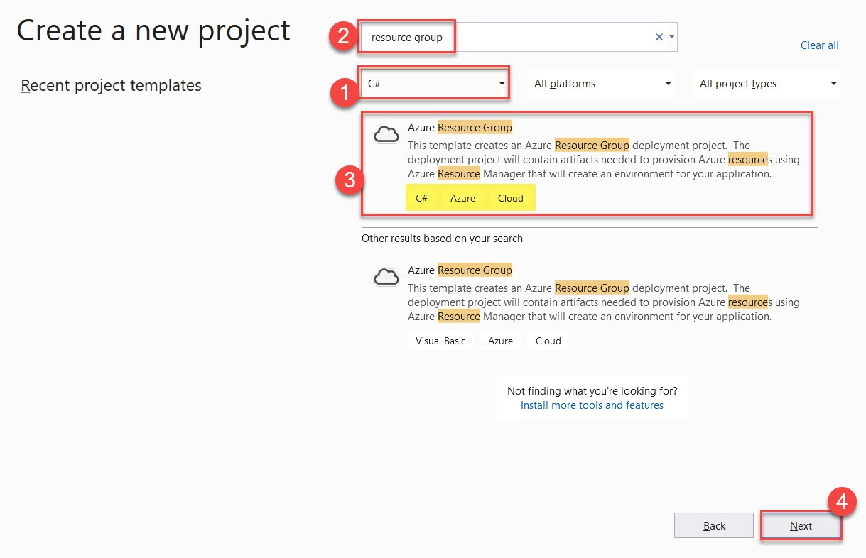

If you want to change Project name you can and click on **Create** button.

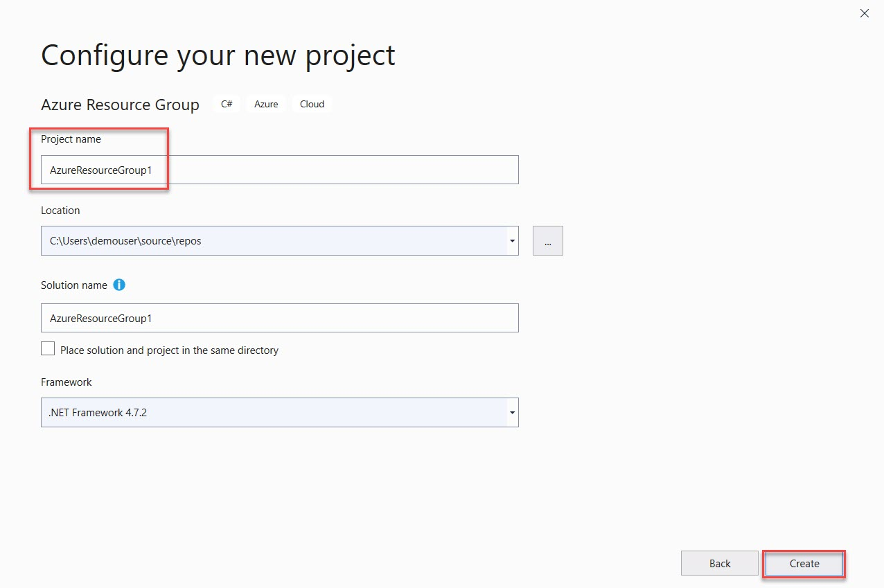

**Step 3:** Select **Blank Template**

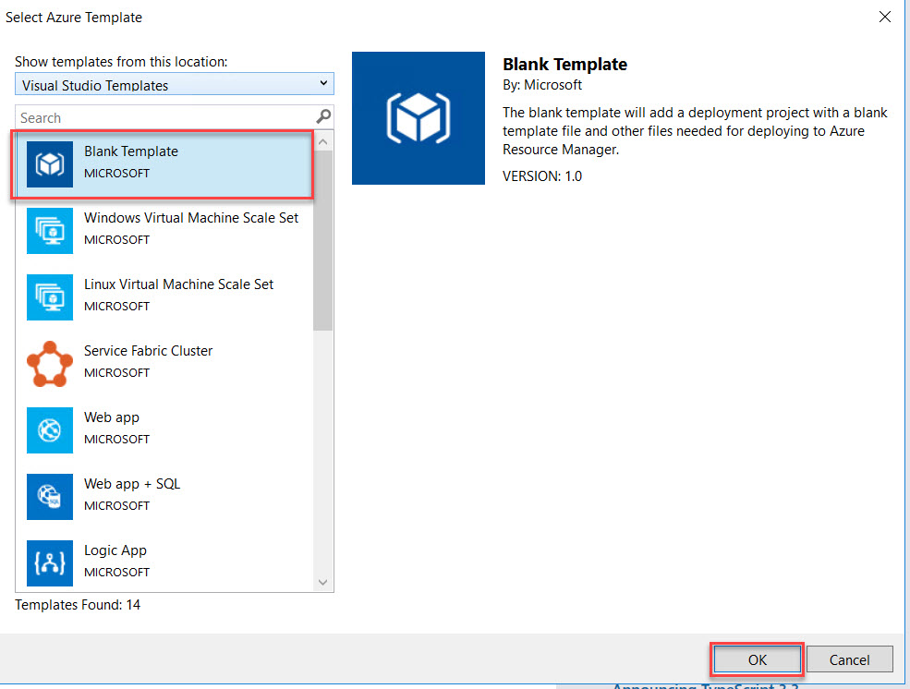

**Step 4:** Open **azuredeploy.json** file

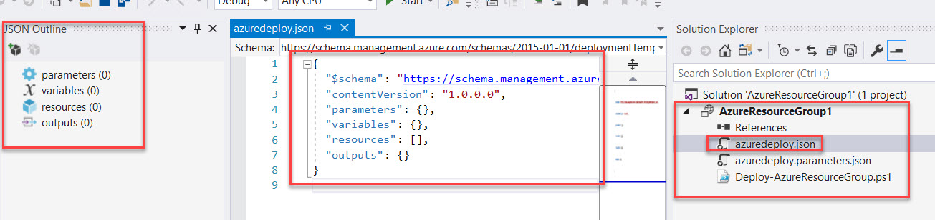

**Step 5:** Left side **JSON Outline** window will be there

Right click on **resource** -> **Add New Resource**

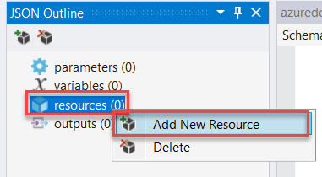

**Step 6:** Search for **Virtual Network**

Name: **TrainingVNET**

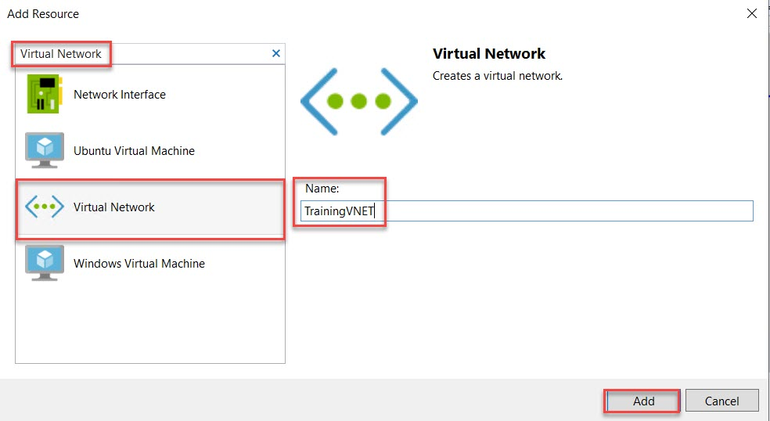

**Step 7:** Navigate to Virtual Network Variables Ex. VNet1, VNet2

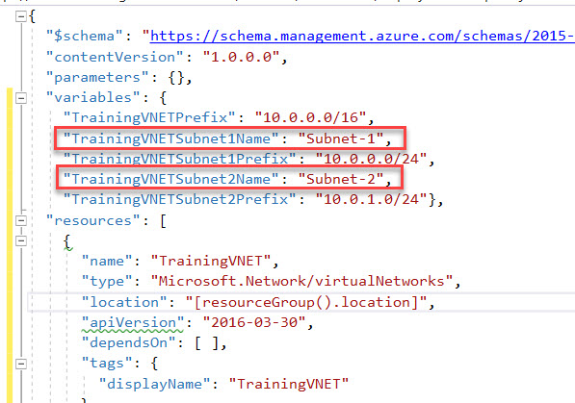

Rename with as below:

"TrainingVNETSubnet1Name": "FrontendNetwork"

"TrainingVNETSubnet2Name": "BackendNetwork"

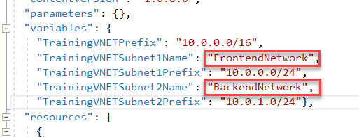

**Step 8:** Right click on **resource** -> **Add New Resource**

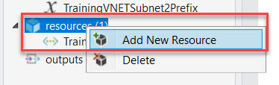

**Step 9:** Search for **Storage**

Name: Use any unique short name because at deployment time extra character will be added by Azure. Ex. **armstrg**

**Note: enter name between 3 to 8 character**

Click on **Add** button

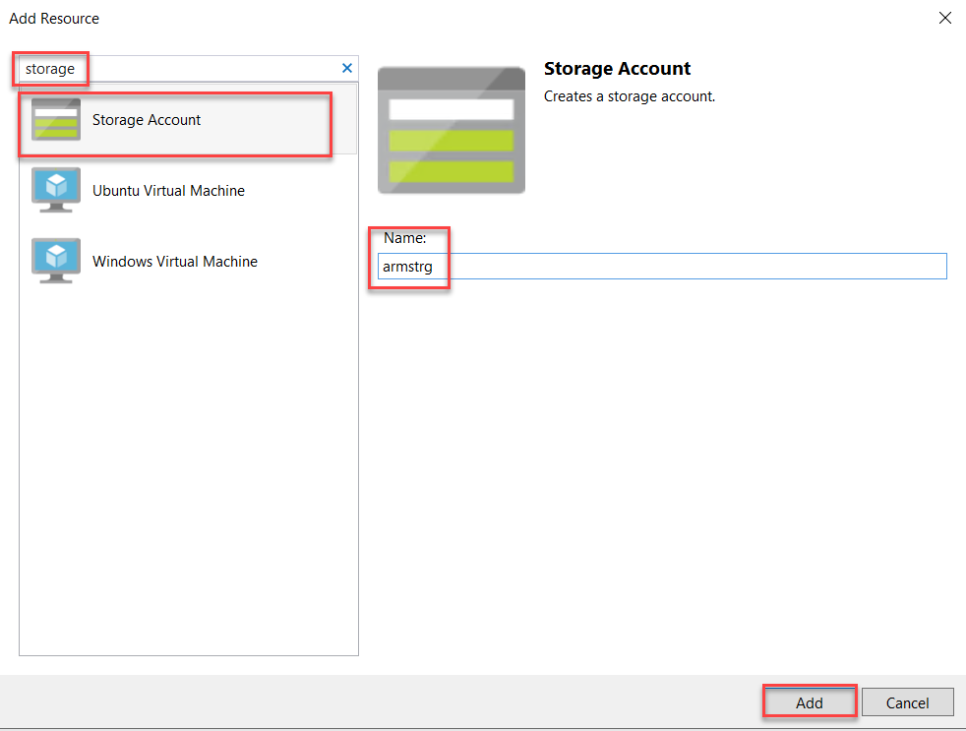

**Step 10:** Select **Storage parameter** and Remove **Standard_ZRS** because for Virtual Machine it’s not supported.

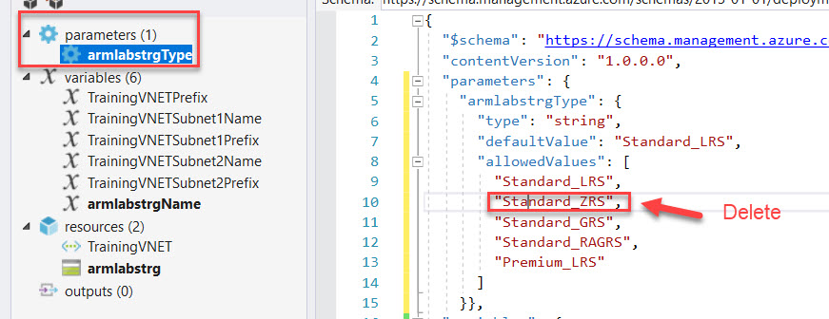

**Step 11:** Also, we are working with database so we get faster operations

Change **defaultValue** to “Premium_LRS”

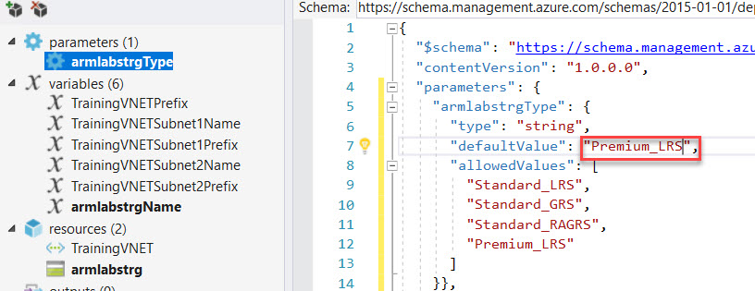

**Step 12:** Right Click on **resources** -> **Add New Resource**

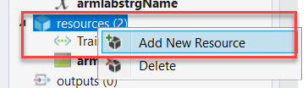

**Step 13:** Search for **Windows Virtual Machine**

Enter Name: **WebVM**

Storage Account: **Choose from list Ex. armstrg**

Virtual network/subnet: **[variables(‘TrainingVNETSubnet1Name’)] (TrainingVNET)**

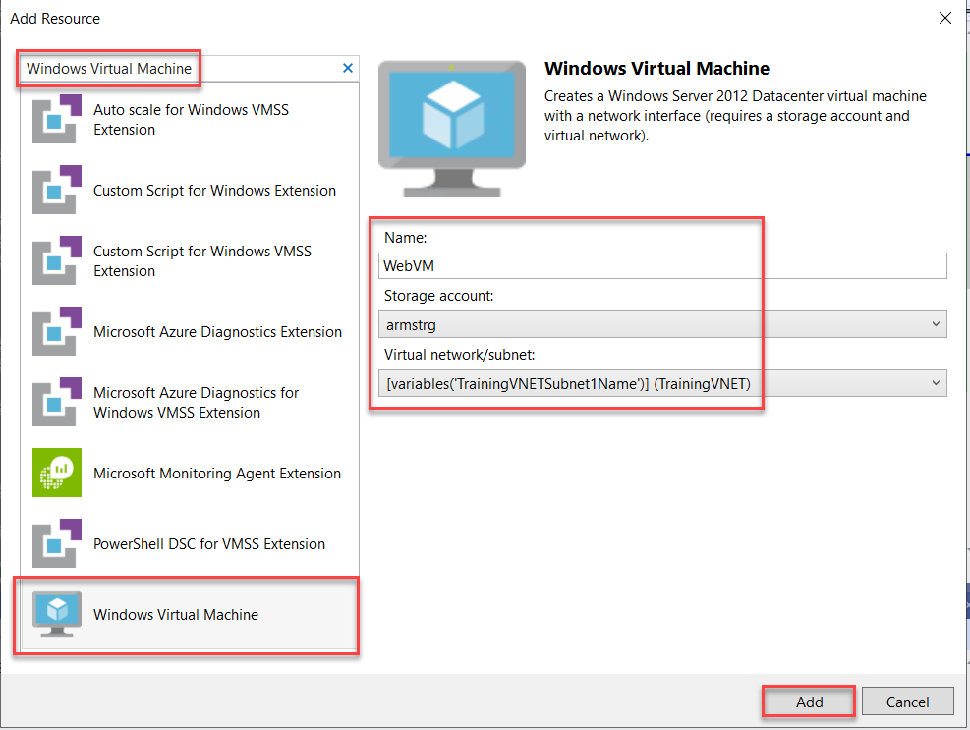

**Step 14:** Select **WebVMVmSize** variable

Check **line no 46** and change size to **Standard_DS1_v2**

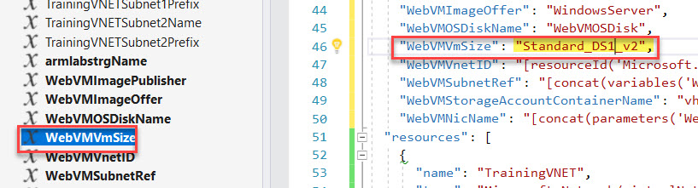

**Step 15:** Right Click on **resource** -> **Add New Resource**

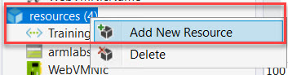

**Step 16:** Search for **Public IP Address**

Name: **WebPublicIP**

Network interface: **WebVMNic**

Click on **Add** button

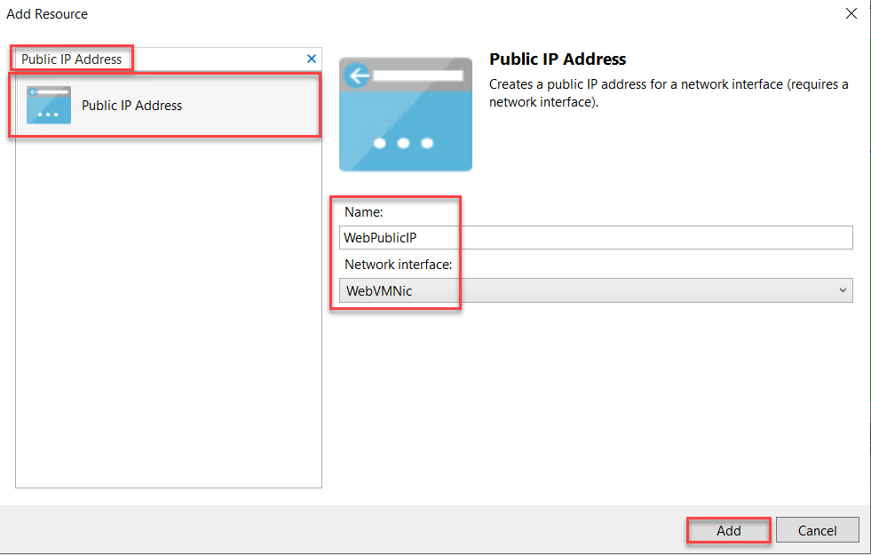

**Step 17:** Right on **resources** -> **Add New Resource**

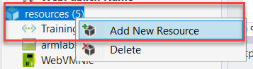

**Step 18:** Search for **PowerShell DSC Extension**

Name: **WebDSC**

Virtual Machine: **WebVM**

Click on **Add** button

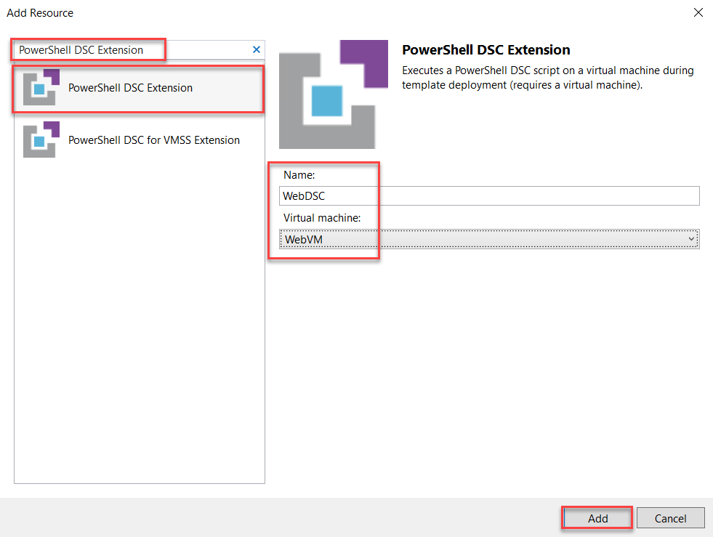

**Step 19:** Open **WebDSC.ps1** from **Solution Explorer**

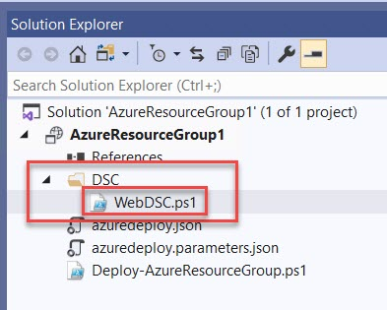

**Step 20:** Remove Default code and update with new code

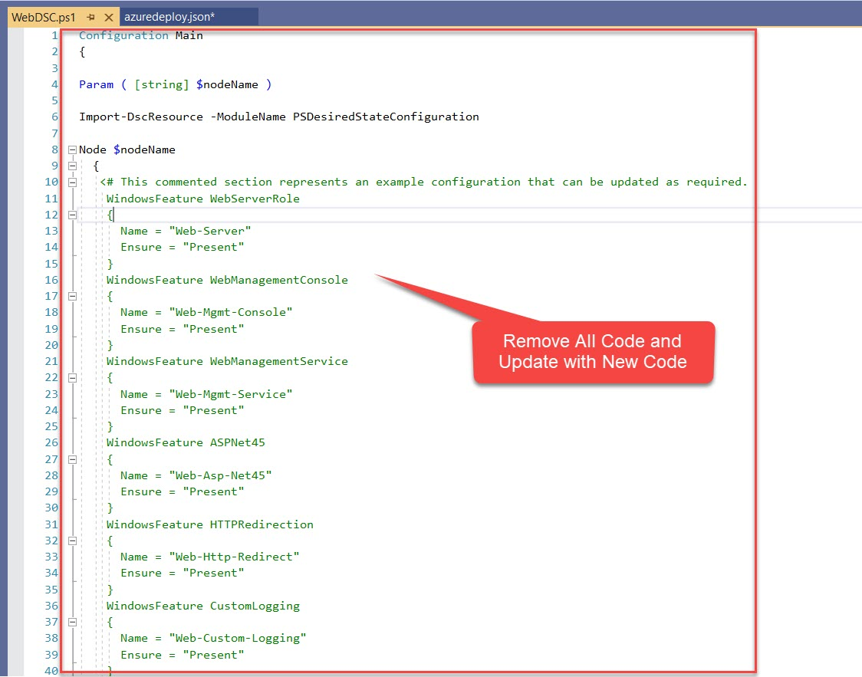

**Step 21:** Navigate to **LabFiles** and Open **ARMWEB.ps1.txt** file

Copy complete code from **ARMWEB.ps1.txt** and paste into **WebDSC.ps1**

**Save** WebDSC.ps1 file.

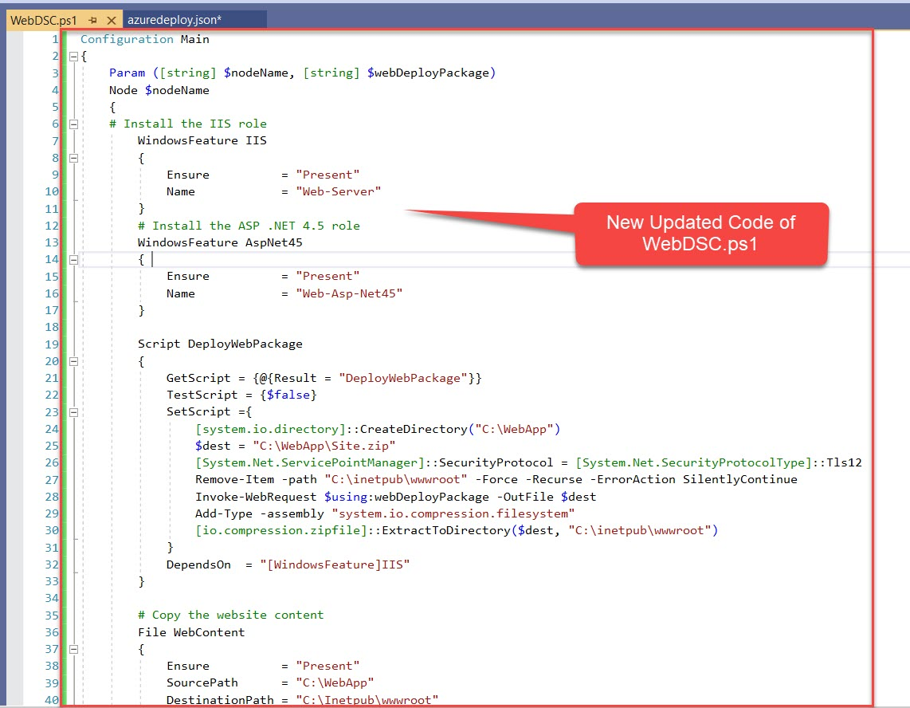

**Step 22:** Again, open **azuredeploy.json** file from **Solution Explorer**

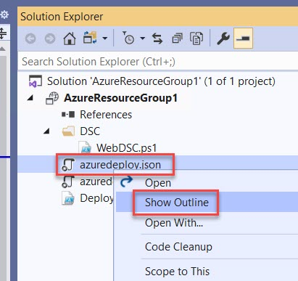

**Step 23:** Select _**artifactsLocationSasToken** parameter

Navigate to **Line No. 51** where **two brackets** available. Select in **between** and **press enter key**

Note: May be line number will be different if any extra line added with this code.

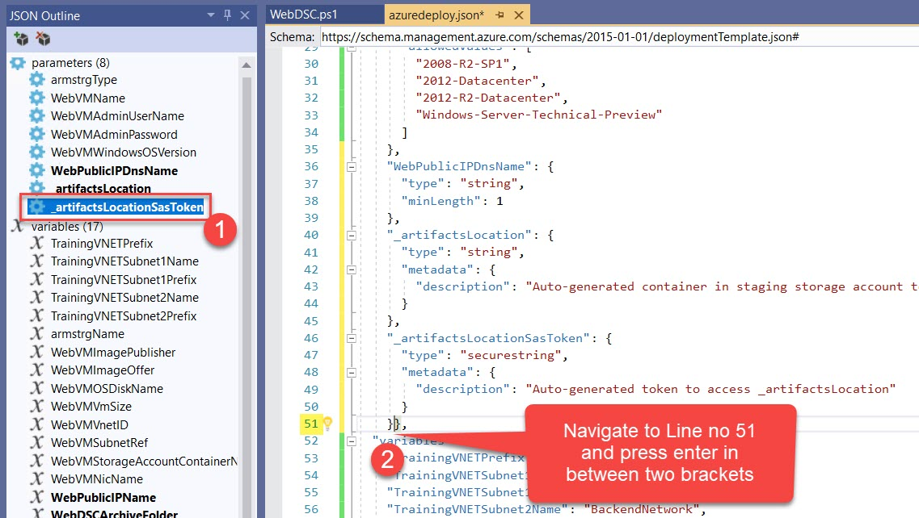

**Step 24:** Add **WebPackage**

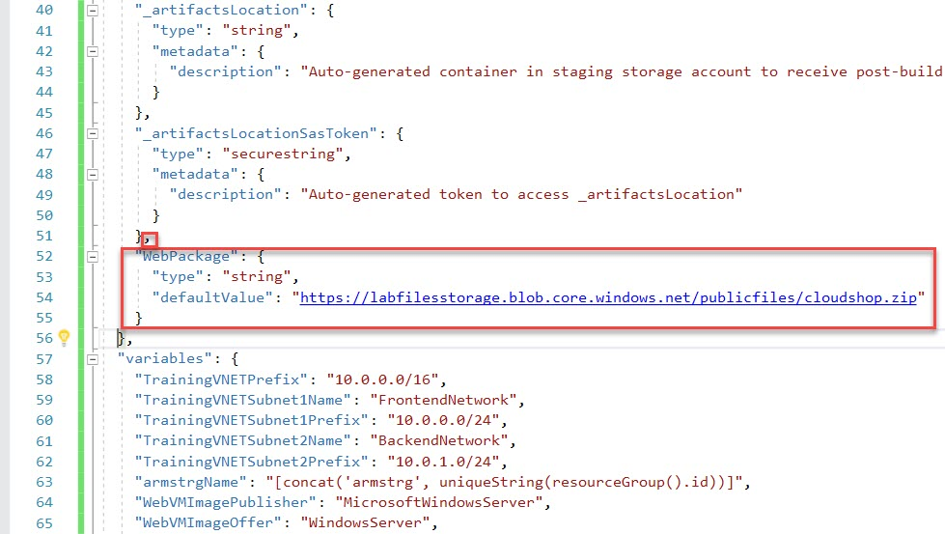

,

"WebPackage": {

"type": "string",

"defaultValue": "https://labfilesstorage.blob.core.windows.net/publicfiles/cloudshop.zip"

}

**Step 25:** Select **WebDSC** resource

First add comma and add below line after **nodeName**

,

"webDeployPackage": "[parameters('WebPackage')]"

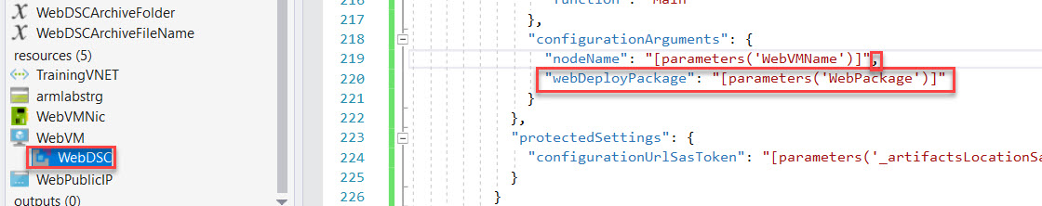

**Step 26:** Right click on **resources** -> **Add New Resource**

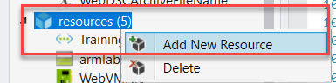

**Step 27:** Search for **Windows Virtual Machine** and enter below details

Name: **SQLVM**

Storage Account: **choose existing storage account** ex. **armstrg**

Virtual network/subnet: **[variables(‘TrainingVNETSubnet2Name’)] (TrainingVNET)**

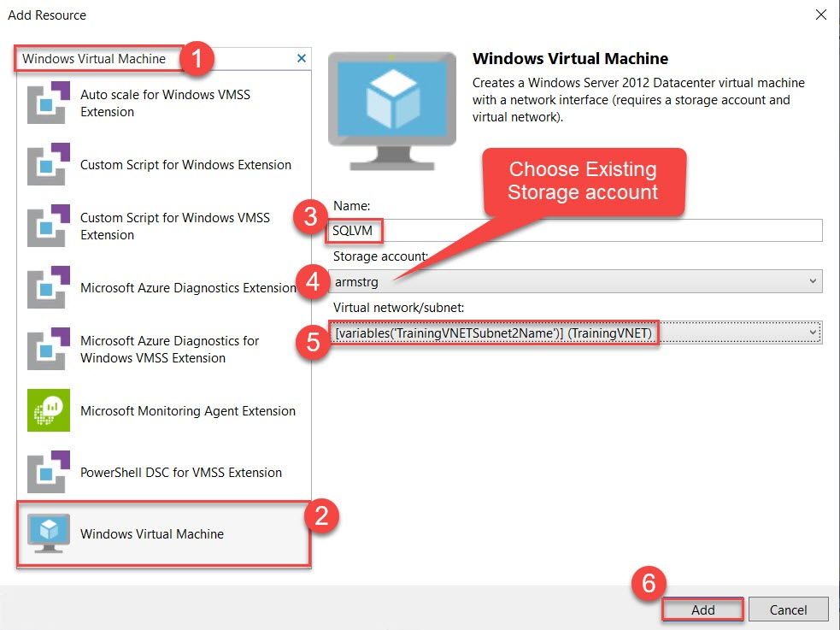

**Step 28:** Select **SQLVMVmSize** parameter

Change to **Standard_DS1_v2**

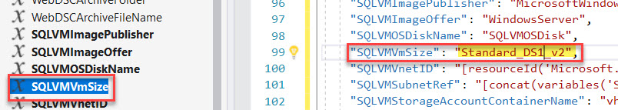

**Step 29:** Select **SQLVMImagePublisher** and **SQLVMImageOffer** variables.

"SQLVMImagePublisher": "MicrosoftSQLServer",

"SQLVMImageOffer": "SQL2014SP2-WS2012R2",

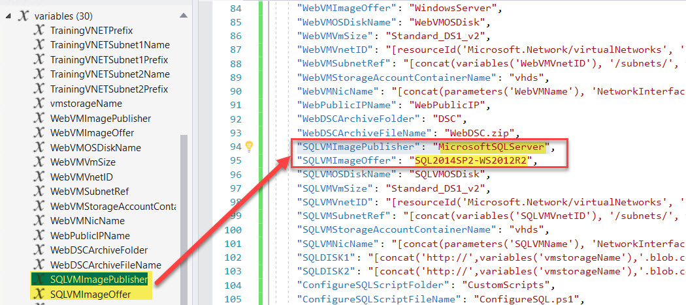

**Step 30:** Navigate to **SQLVMWindowsOSVersion** parameter and delete that block

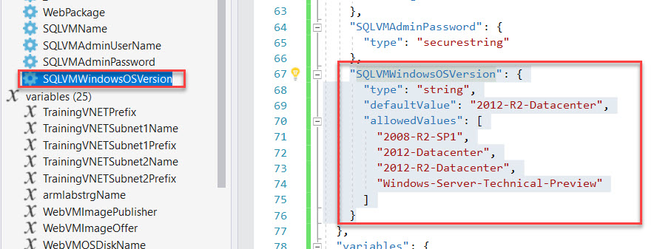

**Step 31:** Add **SQLVMSKU** parameter

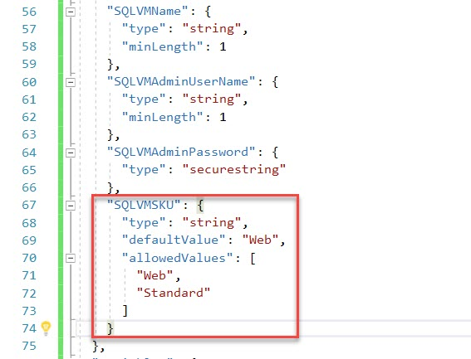

"SQLVMAdminUserName": {

"type": "string",

"minLength": 1

},

"SQLVMAdminPassword": {

"type": "securestring"

},

"SQLVMSKU": {

"type": "string",

"defaultValue": "Web",

"allowedValues": [

"Web",

"Standard"

]

}

**Step 32:** After removing parameter error line will be there

Select **SQLVM** resource rename sku parameter **SQLVMWindowsOSVersion** to **SQLVMSKU**

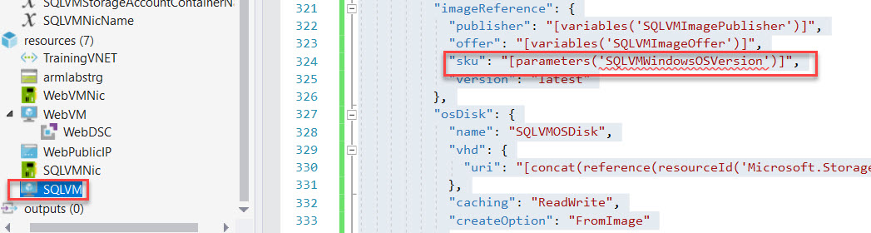

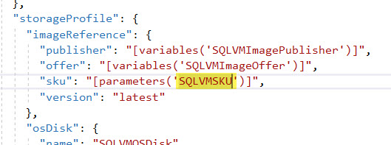

**Step 33:** Select **SQLVMNicName** and Add below code:

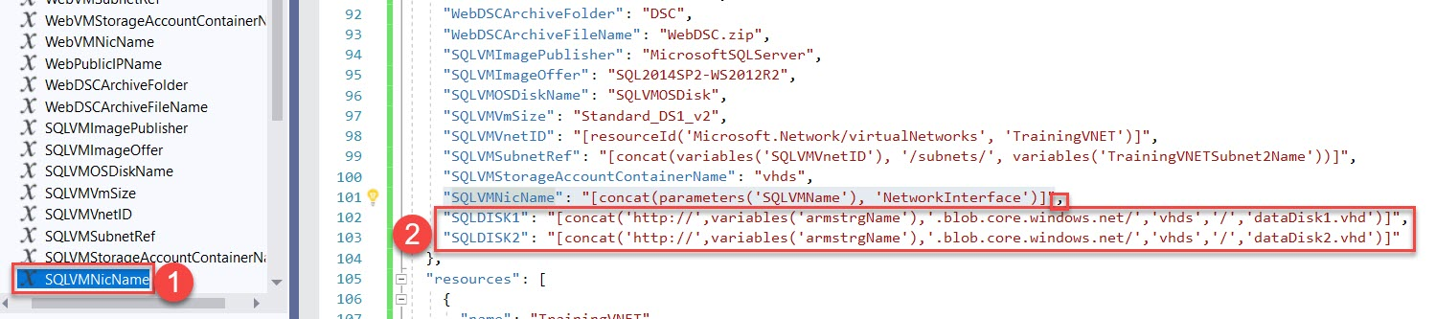

,

"SQLDISK1": "[concat('http://',variables('armstrgName'),'.blob.core.windows.net/','vhds','/','dataDisk1.vhd')]",

"SQLDISK2": "[concat('http://',variables('armstrgName'),'.blob.core.windows.net/','vhds','/','dataDisk2.vhd')]"

**Step 34:** Now add two extra data disks to **SQLVM**

Select **SQLVM** from resources

Add **comma** after **osDisk** block

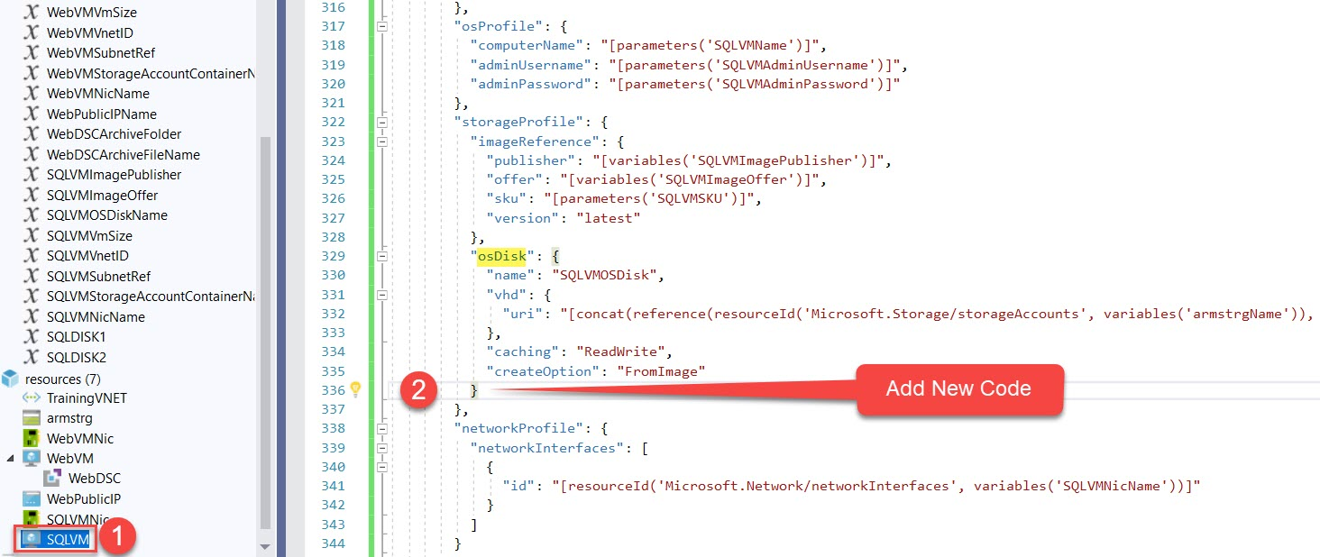

,

"dataDisks": [

{

"name": "datadisk1",

"diskSizeGB": "1023",

"lun": 0,

"vhd": { "uri": "[variables('SQLDISK1')]" },

"createOption": "Empty"

},

{

"name": "datadisk2",

"diskSizeGB": "1023",

"lun": 1,

"vhd": { "uri": "[variables('SQLDISK2')]" },

"createOption": "Empty"

}

]

**Step 35:** Add New Resource

Right click on **resources -> Add New Resource**

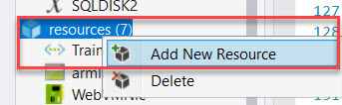

**Step 36:** Search for **Custom Script for Windows Extension**

Name: **ConfigureSQL**

Virtual Machine: **SQLVM**

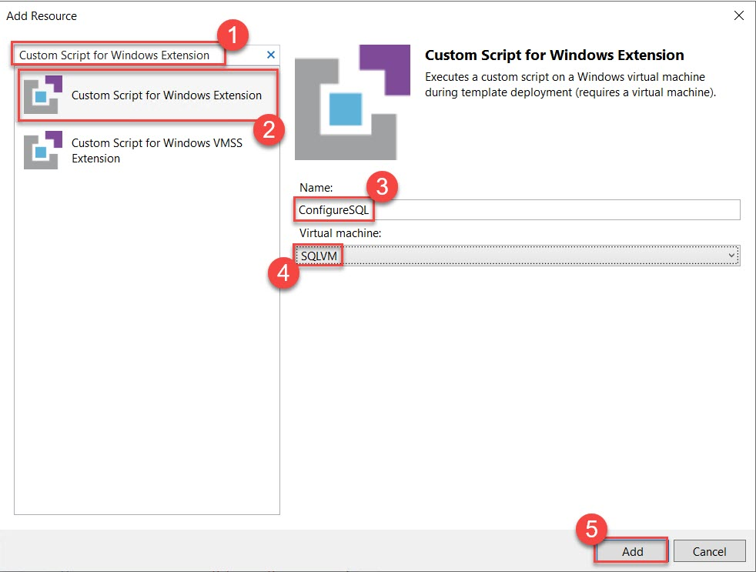

**Step 37:** Open **ConfigureSQL.ps1**

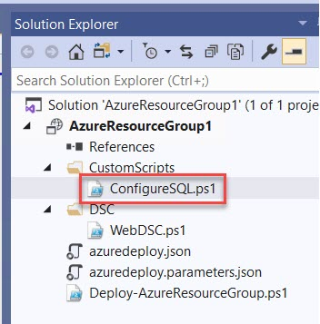

**Step 38:** Remove all code.

Open **ARMSQL.ps1.txt from LabFiles Folder**

**Copy and Paste into ConfigureSQL.ps1**

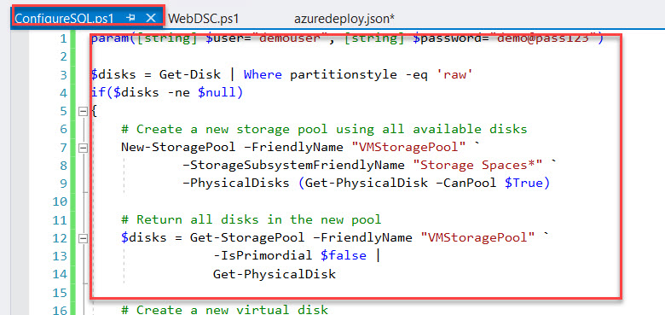

**Step 39:** Once again, open **azuredeploy.json** file

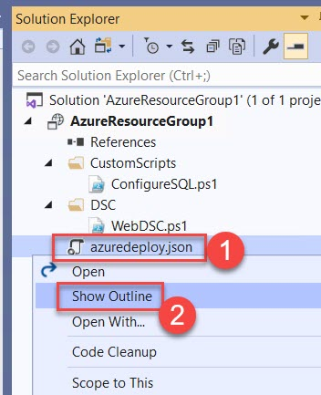

**Step 40:** This extension requires the local administrator credentials passed to it at deployment time. To accomplish add a new variable at the end of the Variables section.

Add **Comma**

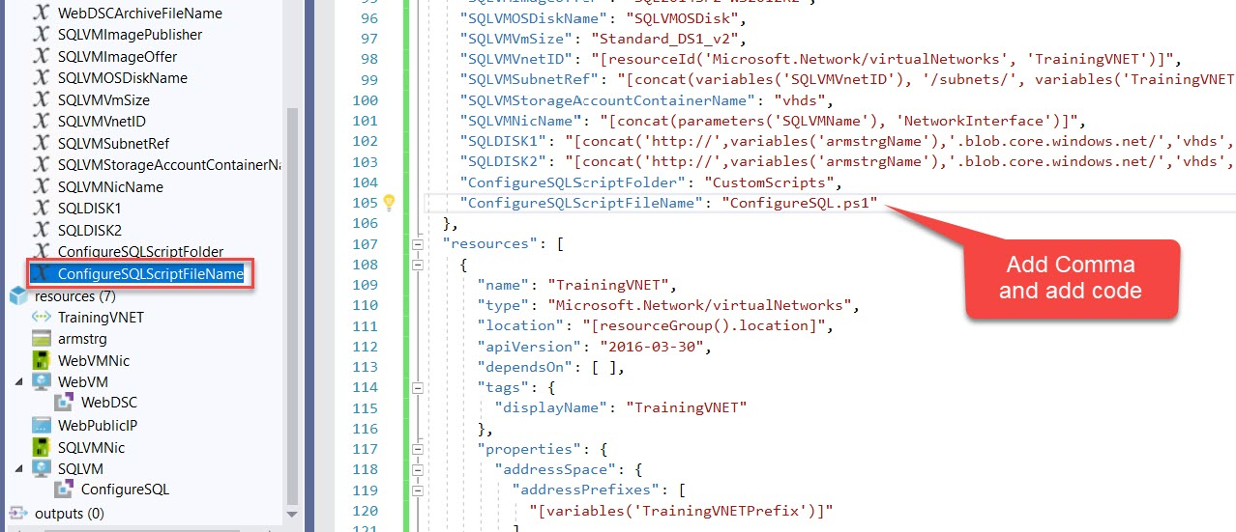

**Step 41:** Paste below code:

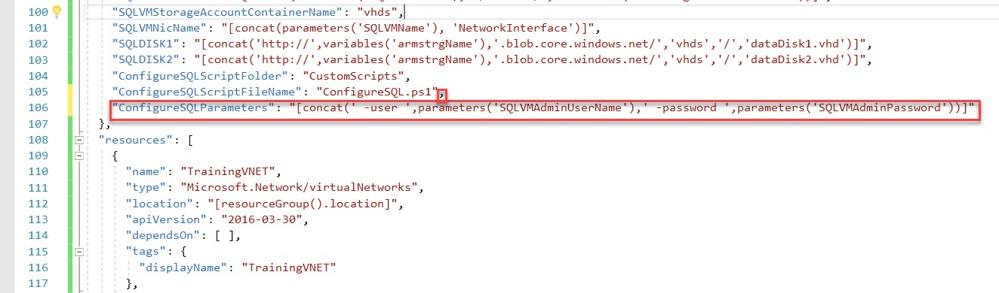

,

"ConfigureSQLParameters": "[concat(' -user ',parameters('SQLVMAdminUserName'),' -password ',parameters('SQLVMAdminPassword'))]"

**Step 42:** Select **ConfigureSQL** resource

**autoUpgradeMinorVersion** attribute will automatically use the latest minor version of the customScriptExtension. To avoid the risk of automatic updates breaking your script, set this property to false on the **ConfigureSQL** custom script extension.

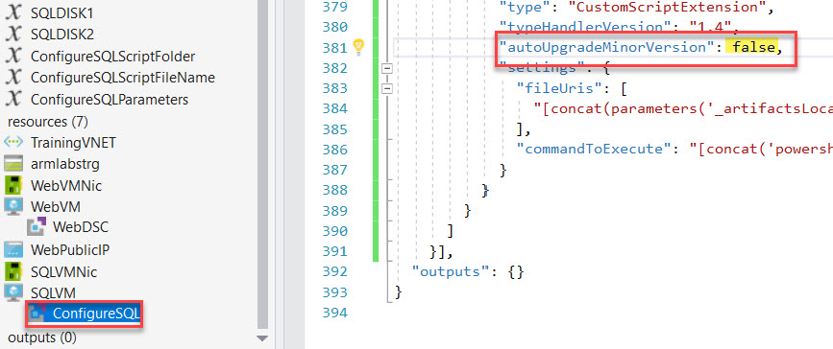

**Step 43:** Find the line that begins with "**commandToExecute**", and replace the entire line with the following

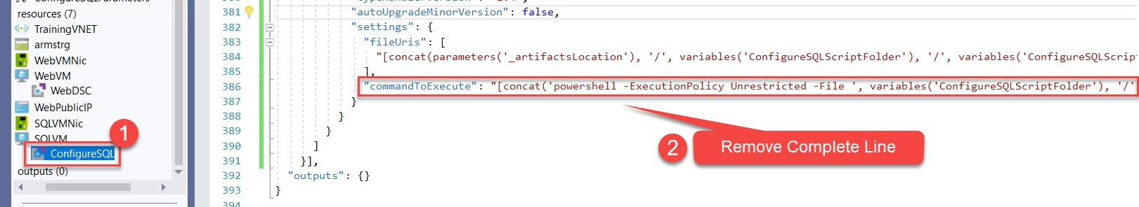

**Step 44:** Update with below code:

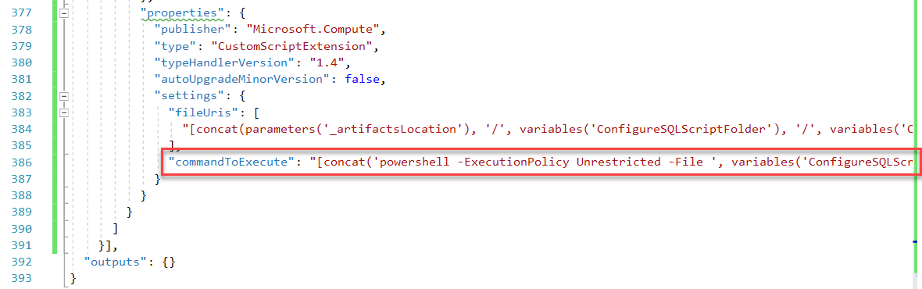

"commandToExecute": "[concat('powershell -ExecutionPolicy Unrestricted -File ', variables('ConfigureSQLScriptFolder'), '/', variables('ConfigureSQLScriptFileName'), ' ', variables('ConfigureSQLParameters'))]"

**Step 45:** Right Click on **Project Name** -> **Deploy** -> **New…** option

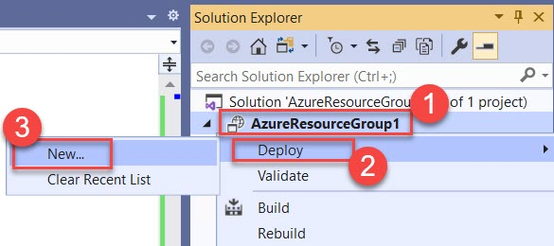

**Step 46:** If Azure account not configured to enter Azure credentials.

Create **New Resource Group**

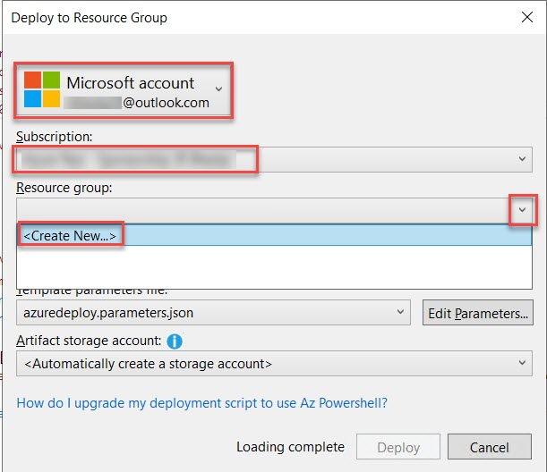

**Step 47:** Resource Group Name: **ARMLABRG**

Resource Group Location: **West US**

Click on **Create** button

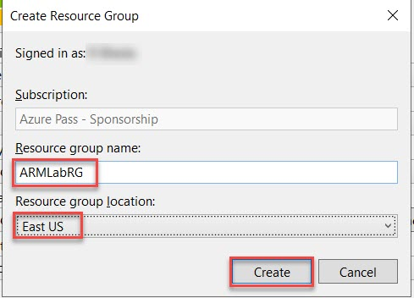

**Step 48:** Click on **Edit Parameters…** option

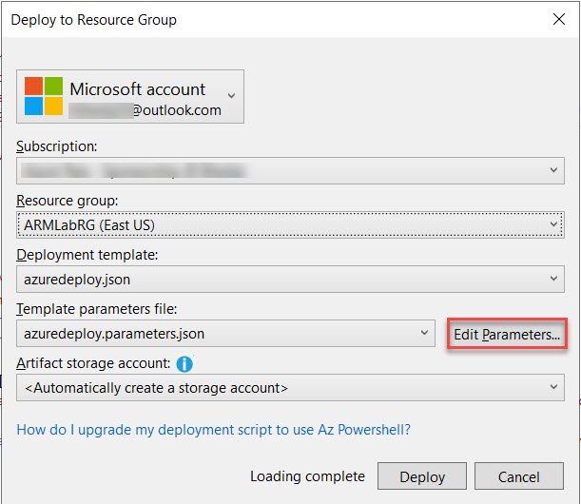

**Step 49:** Edit Parameters

**Note: Use below details except WebPublicIPDnsName otherwise might be you will receive error**

WebVMName: **armweb**

WebVMAdminUserName: **demouser**

WebVMAdminPassword: **demo@pass123**

WebPublicIPDnsName: **armpip (enter unique name Ex. armpip123)**

SQLVMNAme: **armsql**

SQLVMAdminUserName: **demouser**

SQLVMADAminPassword: **demo@pass123**

tick mark **save passwords as plain text in the parameters file** and **Save** button.

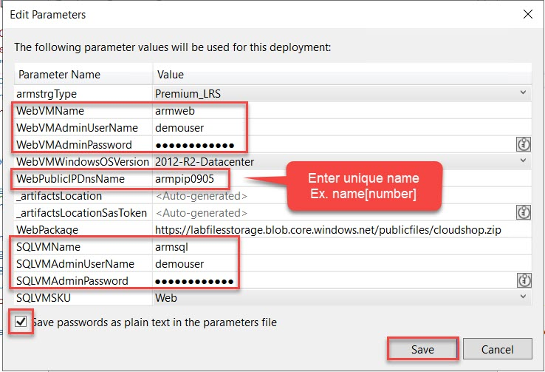

**Step 50:** Click on **Deploy** button

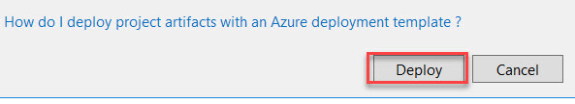

**Step 51:** Wait for **5 to 15 minutes** to deploy all resources (2 VMs with extensions)

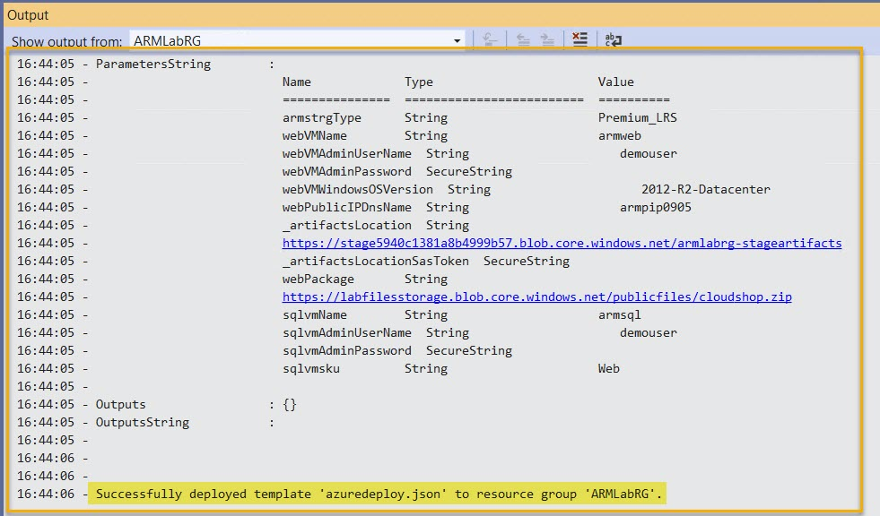

**Step 52:** Navigate to **Azure Portal**

Click on **Resource Groups** -> **ARMLabRG**

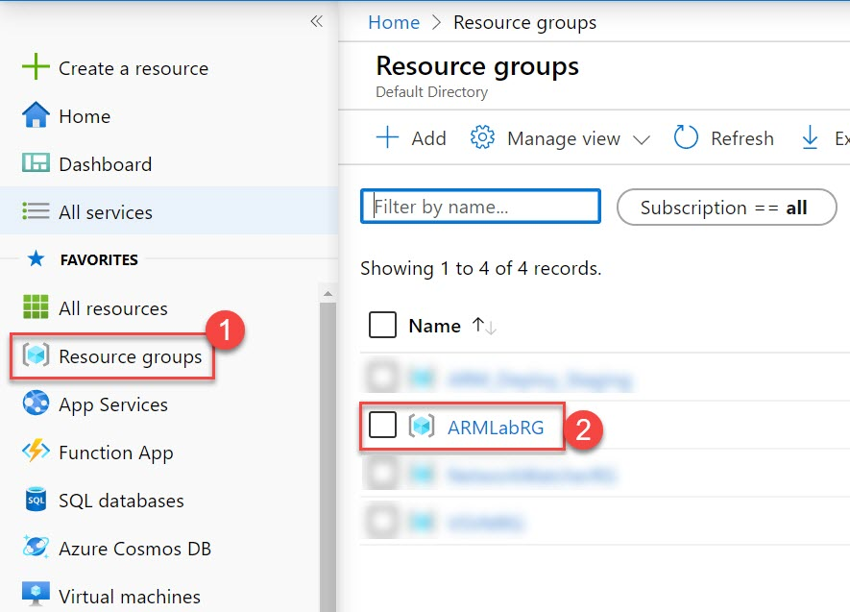

**Step 53:** Select **armweb** Virtual Machine

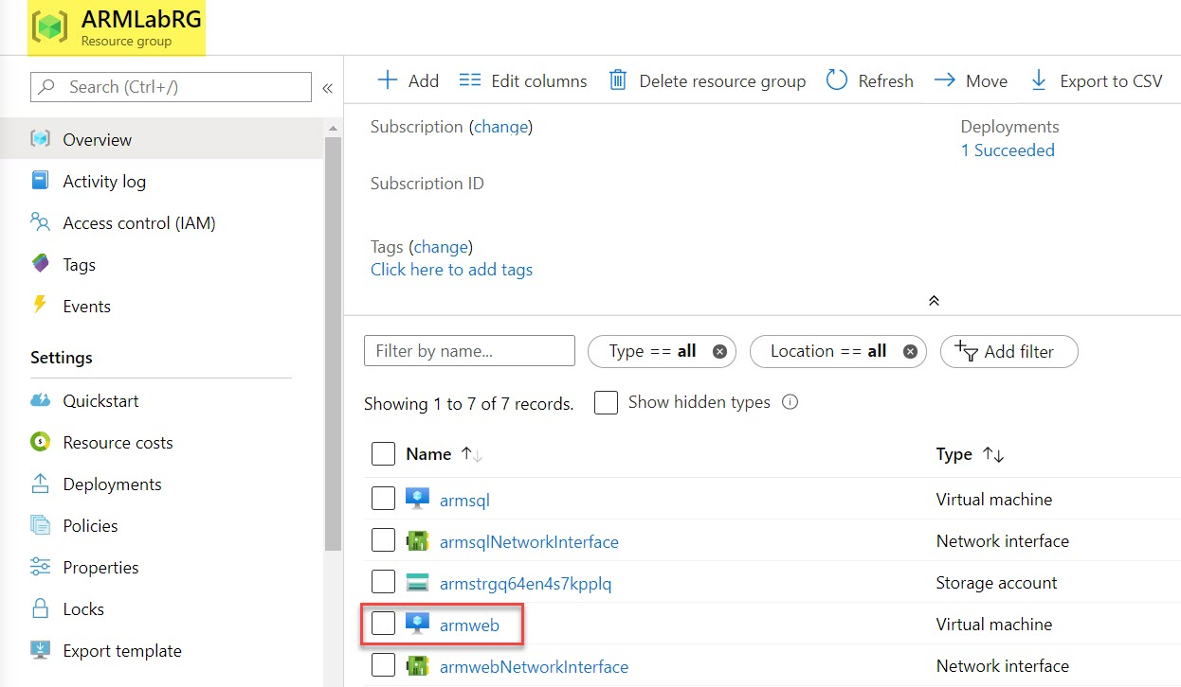

**Step 54:** Copy **DNS name of** **Virtual Machine** ex. armpip.eastus.cloudapp.azure.com

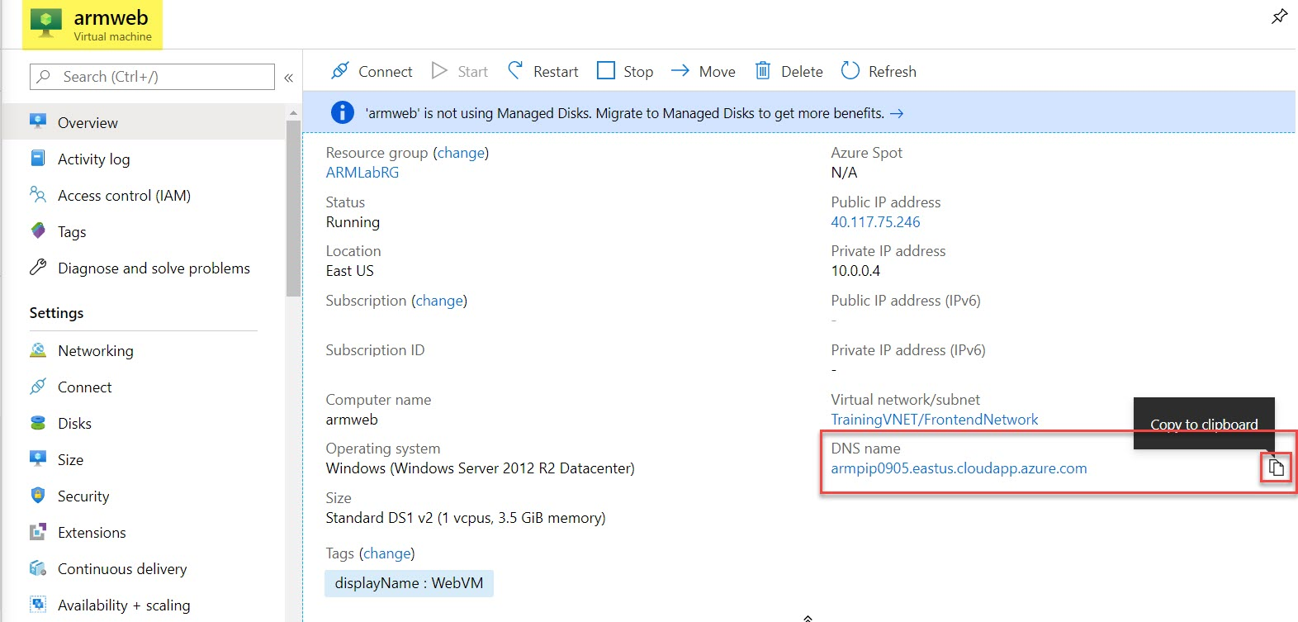

**Step 55:** Open Browser and paste that link.

Website with Database will load as below:

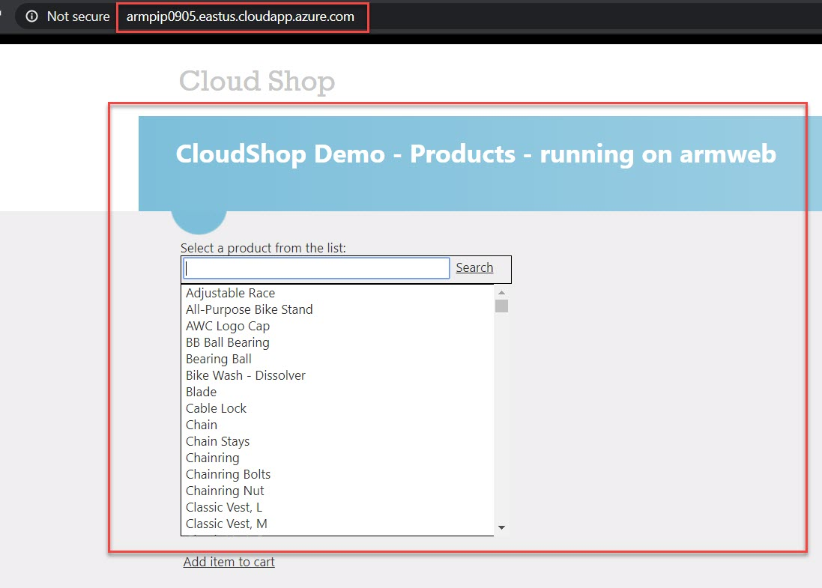

Note: **Website** accessing from **WebVM** and **Database** accessing from **SQLVM**.

RDP can perform by **Private IP Address** of SQLVM via WebVM

If Lab completed please delete **ARMLabRG** resource group.